Lesson 10.6 Friction

Recommended teaching time for this lesson: 1 x 60 minute period

• 35 minutes of explicit teaching

• 25 minutes of suggested classroom activities

• 45 minutes homework

Getting started

Key ideas

* Friction is caused by adhesion forces between two objects in contact.
* Frictional forces oppose applied forces.
* Friction can be overcome by applying an opposite force that is larger than the frictional force.

Curriculum links

Science understanding

* Identify forces acting on an object.
* Determine the resultant force acting on an object in one dimension.
* Solve problems using of the laws of classical mechanics and $a=\frac{F_{net}}{m}$.

Advice for teaching this lesson

Things to know before you start teaching

Friction is a reactionary force. It does not exist until there is an ‘attempt’ at motion. This means that the magnitude of force can be calculated quite easily – though this is outside the scope of the syllabus –but the direction will change depending on all other circumstances as friction will not appear until the very end.

Common misconceptions

* Students often forget that friction is involved in the calculation of net forces. Free body diagrams and vector sums will help with this.

Differentiation strategies

Help students progress through friction scenarios in a step-by-step process. Visualising the scenario with drawings will help reduce cognitive load in processing questions.

Starter activity: Resisting movement

Approximate time: 5 minutes

**Activity placement:** Place directly after Lesson overview

**Activity summary:** A small hands-on activity to introduce friction force as a form of resistance to movement.

Notes for the teacher

You may like to bring some scrap paper for students to use.

Instructions for students

Step 1: Push your hand into the desk and attempt to slide your hand along the desk.

Step 2: Now put a piece of paper between your hand and the desk. Your teacher may have some scrap paper you can use. Repeat Step 1 with the piece of paper between your hand and the desk.

* 1. Under which circumstances was it easier to move your hand?
  2. What did you feel when trying to slide your hand under each circumstance?

Answers

1. Students should find that sliding their hand with the piece of paper under it was easier.\
2. Student answers will vary. Examples may be that their hand warmed up, that the hand stuck and slid repeatedly without the paper or that the paper made the slide easier.

Classroom activity: The myth of the phone book

Approximate time: 10 minutes

**Activity placement:** Place directly above “Challenge”

**Activity summary:** A video demonstrating how high the amount of force can be generated by friction in very common items.

Notes for the teacher

If your school has access to Clickview, there is an excellent video by Todd Sampson who demonstrates this phenomenon to perform a bungie jump with a rope held together by two phone books interlaced. The show is called “Life on the Line”. It has several excellent physics-related videos.

You can demonstrate this with junior science textbooks fairly easily. You don’t need to interleave every page to get a good amount of friction, even small amounts of pages, 5 to 10 for example, can let students experience this for themselves.

Instructions for students

Step 1: Watch the following video.

Phone book fables | MythBusters: <https://www.youtube.com/watch?v=Y89MUYZKaME>

1. Describe the term ‘kinetic friction’. Note that the text calls this dynamic friction.
2. Describe the term ‘static friction’ using observations from the video.

Answers

1. Kinetic friction is the amount of friction force felt as two objects slide relative to each other.
2. Static friction is the amount of friction force felt when two objects attempt to slide relative to each other, but do not move.

Classroom activity: Where’s the friction?

Approximate time: 10 minutes

**Activity placement:** Place directly above “Check your learning 10.6”

**Activity summary:** This activity requires students to consider where friction will occur after other forces are applied.

Notes for the teacher

Remind students that friction is reactionary and only appears last in a scenario.

Encourage students doing the core activity to draw their free body diagrams.

Instructions for students

For each of the scenarios below, determine the direction in which friction will act.

1. Pushing a crate to the right
2. Pushing a crate to the right with 10 N of force, and to the left with 15 N of force
3. Pushing on a crate to the right and on the left with equal-sized forces
4. Lifting a crate upwards

Helpful hints

* Consider the forces that are given and how they would move the object, and then add friction at the end.
* Sometimes ‘none’ is an answer.

Support activity

Notes for the teacher

This version provides diagrams for students to use.

Instructions for students

For each of the scenarios shown below, determine which direction friction will act.

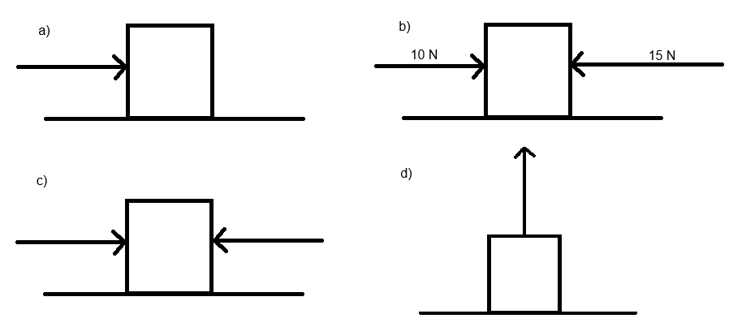

1. Pushing a crate to the right.
2. Pushing a crate to the right with 10 N of force, and to the left with 15 N of force.
3. Pushing on a crate to the right and on the left with equal sized forces.
4. Lifting a crate upwards.

Challenge activity

Notes for the teacher

This set of scenarios is to reinforce that friction is reactionary. Scenario A reinforces friction opposing motion. Scenario B results in friction being flipped as the movement of the crate is now up the slope, so it continues to oppose motion. For scenario C however the upwards force overcomes gravity, but the crate still does not move, meaning the friction acts to oppose the upwards push.

Instructions for students

For each of the scenarios below, determine which direction friction will act. A diagram of gravity acting on the slope has been included to help you visualise them. You will learn more about the action of forces on a slope in Unit 3.

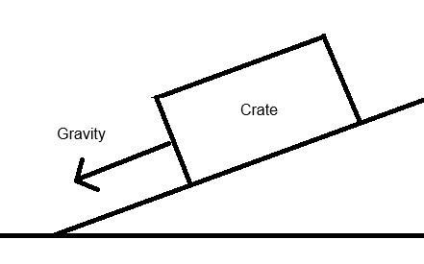

1. A crate sliding down a slope while gravity pushes down the slope at 10 N.
2. A crate being pushed up a slope at 20 N, while gravity pushes down the slope at 10 N.
3. A crate being pushed up the slope at 15 N, while gravity pushes down the slope at 10 N, but the crate doesn’t move.

Answers

1. Friction acts to the left
2. Friction acts to the right
3. There would be no friction
4. No friction as there is no relative movement

Support activity

1. Friction acts to the left
2. Friction acts to the right
3. There would be no friction
4. No friction as there is no relative movement

Challenge activity

1. Friction acts up the slope
2. Friction acts down the slope
3. Friction acts down the slope